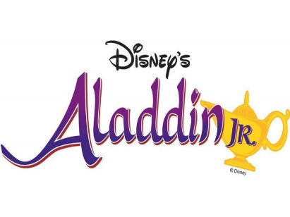
Aladdin
Audition Process:

To audition for Aladdin, you will need to complete the following tasks and turn in your clearance card to Mrs. Latz before you audition.

Name ______________________________________________ Grade ___________
Check when completed | Task | Special Note
 | - Read the packet. Rehearse for the audition. | When rehearsing ask someone how to pronounce words you do not know.
 | - Sign up for text/email reminders on PAGE 2 and have your parents do the same. | You and your parent must sign up to audition
 | - Complete the audition packet and volunteer form.
 | - Return audition packet to Mrs. Latz (be sure to indicate whether your parents will volunteer and/or you need a scholarship) and pick up the fee statement and emergency contact form. | Mrs. Latz will not issue a fee statement if you have not completed steps 2 and 3
 | - Complete the emergency contact form and write a check for the participation fee (make checks payable to Philomath Middle School).
 | - Return the emergency contact form, fee statement and check to the office to receive your clearance card. | This step is CRUCIAL!
 | - Bring your clearance card to auditions. | DON’T WAIT TIL THE LAST MINUTE!

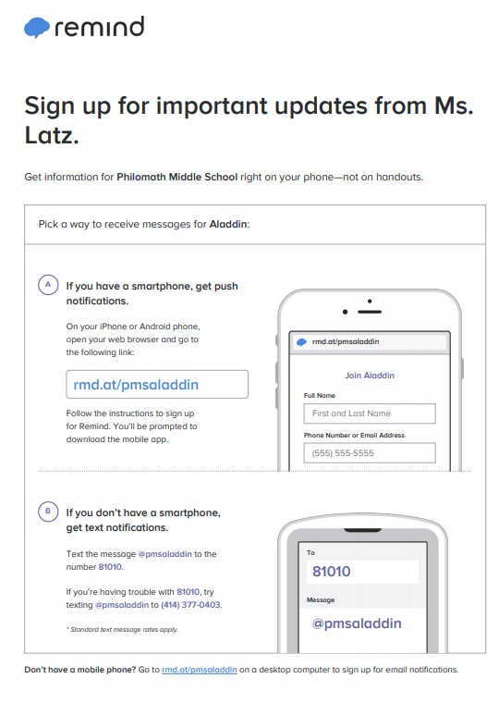
Aladdin
Audition Information

Auditions: Mon/Tue Dec. 10 and 11th 3:15-5:00
Place: PMS Library
Who: Any current PMS student
Callbacks: Wed. Dec. 12th 3:10-4:15- Band Room (This MAY be changed to lunch time)
First read through: Thursday- December 13- 3:15-5:15 –PMS Library-Bring Script
Practice Tuesday – Thursday, Dec. 18-20th 3:15 – 5:00

**Auditions include reading a part and singing (for everyone). We realize that not everyone is a confident singer and we will not place you in a solo role if you are not ready for it. There are roles that include little singing, roles that include only singing with a group and roles that include solo, duet or trio singing. We will work very hard to place you where you will be able to contribute to the overall success of the show. We will also work hard to include as many students as possible. The cast list will be posted on Mrs. Latz' school website by Wednesday, December 12 by 8:00pm.
http://latzjole.yolasite.com/aladdin.php
The links to the Aladdin CD’s are at the above address also.

Not everyone will get the part they want, but we appreciate good attitudes and the willingness to contribute. Be prepared to come to the first reading with a good positive attitude.
In order to audition, each student must have completed the steps on the first page and bring their clearance card to the audition.
The participation fee of $85 can be paid at the office prior to auditions. Please make checks payable to Philomath Middle School. The fee will be reduced to $65 if a parent is willing to volunteer for at least 2 hours.
If you are in need of a scholarship because of financial hardships (up to $50 scholarship), please have your parent write a note requesting the amount needed and return this note with the audition packet to Mrs. Latz.
7th/8th grade basketball players through the school will be able to participate on a limited basis. We will work with your coach for you to attend a minimum number of rehearsals to add to the success of the play. Because this is the only school sponsored conflict, it is the only thing (other than illness/emergency) that will be excused.

Unfortunately, appointments (routine dentist, eye etc), music lessons, dance, other sports etc. will not constitute an excused absence and therefore must be worked around the play rehearsals and performances.

The Philomath Middle School production of “Aladdin” will rehearse Mon- Thurs December 13 –March 6 (except December 17th). The performances are: March 7, 8 and 9 at 7:00 pm; March 7 and March 9 at 1:00pm and March 11 at 9:00 a.m., during the school day. Students must be committed to be at every rehearsal and performance as assigned with the exception of illness and emergency. Students that have more than one unexcused absence or tardy may be asked to leave the play. Students also need to understand that their behavior and preparedness are to be of the highest quality to contribute to the success of the show. Students that misbehave or have low effort as determined by the director may be asked to leave the show.

(Seven people) Genie, Aladdin, Shop Owner, Kassin, Babkak, Omar, Razoul

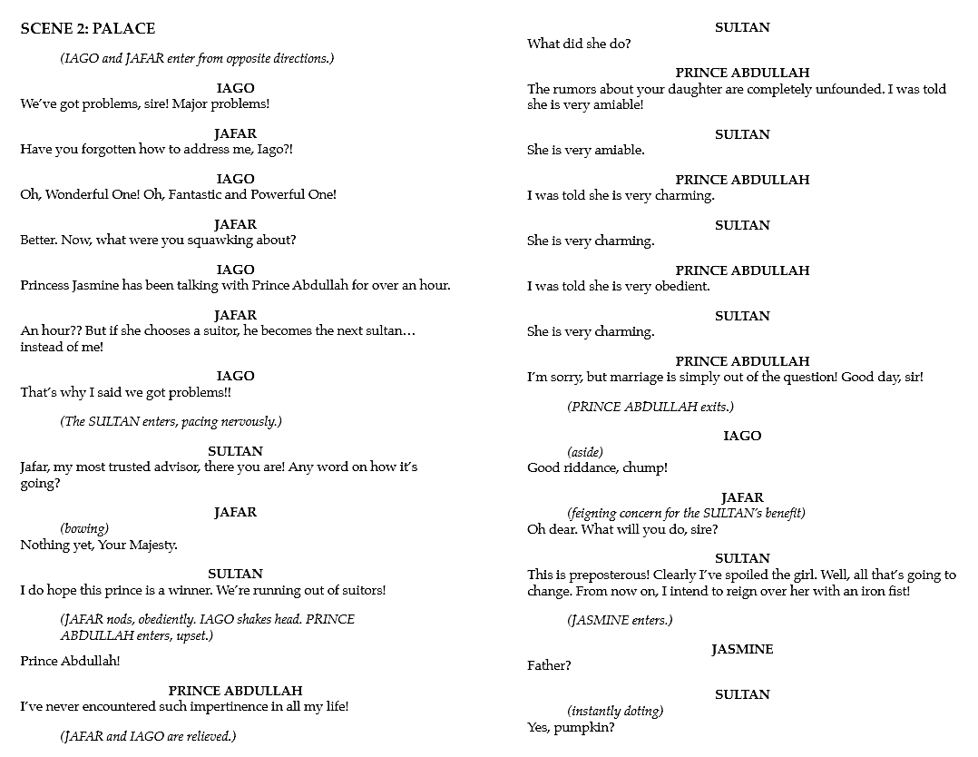

Four people- Iago, Jafar, Sultan, Prince Abdullah

Five people- Aladdin, Iago , Jafar, Jasmine, Razoul
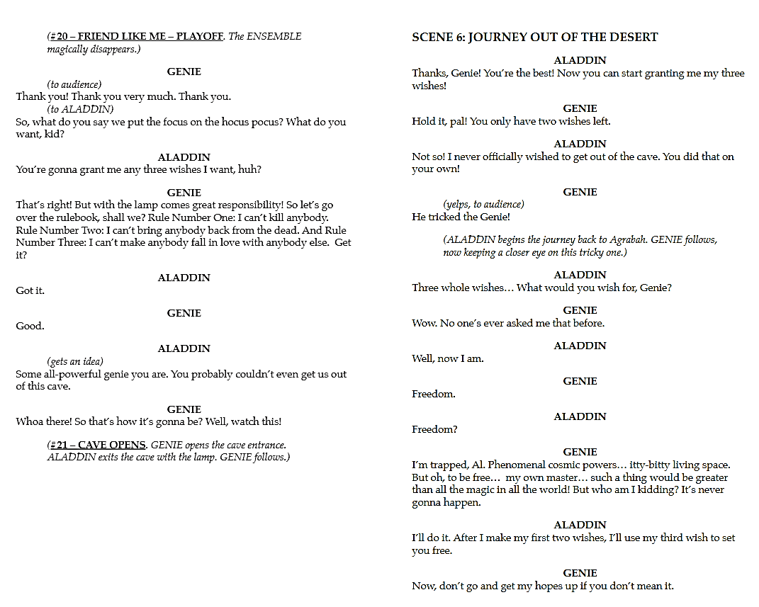
Two People- Genie and Aladdin

Aladdin Audition Form

Name ____________________________
Grade____ Height ______ T-shirt Size ______ (Youth or Adult) Shoe Size _____
Address __________________________________________________________________________

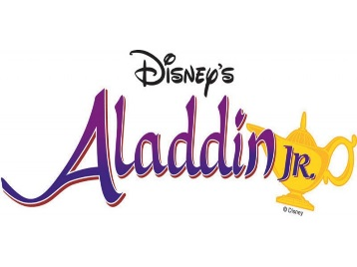
Phone number ___________ ___________ Parent email ________________________________
^{(Student)} ^{(Parent)}
I would be interested (check all that apply) in:

____ Small Part ____ Big Part ____ Singing only with a group _____ Any singing
____ I am a 7/8 grade basketball player (can work out special schedule)

The Fee is $85 to participate and make check payable to Philomath Middle School.

A $20 discount is available for parents that are willing to volunteer two or more hours to this program. If you can volunteer, please complete the reverse side of this form and make check payable to Philomath Middle School for $65.
************************************************************************
The Philomath Middle School production of “Aladdin” will rehearse Mon- Thurs December 13 –March 6. The performances are: March 7, 8 and 9 at 7:00 pm; March 7 and March 9 at 1:00 pm and March 11 9:00 a.m., during the school day. Students must be committed to be at every rehearsal and performance as assigned with the exception of illness and emergency. Students that have more than one unexcused absence or tardy may be asked to leave the play. Students also need to understand that their behavior and preparedness are to be of the highest quality to contribute to the success of the show. Students that misbehave or have low effort as determined by the director may be asked to leave the show.

__________________________________ ______________________________
(Student Signature) (Parent Signature)
There is a $85/$65 participation fee.
Partial scholarships are available (up to $50) on a need basis – please send a note with your child explaining the amount needed.
(turn over)
PARENT VOLUNTEER FORM
In order to be eligible for the reduced tuition of $65, a parent must be willing to volunteer at least 2 hours
[A parent Volunteer Coordinator will contact you to confirm your volunteer job(s)]

Check all that apply and please sign up for more than one option.

______ Supervision _______ Set construction
_______ Sewing _______ Hair/Make-up
_______ Ticket taking _______ ART work
_______ Auditorium Set-up _______ Set take down
_______ Clean up _______ Volunteer Coordinator
_______ Program design/typing _______ Photographer
_______ Photograph Printing _______ Buy/cook food for Dramathon
_______ Help to serve/prepare food at Dramathon _______ Head up the Children’s Tea
_______ Work/decorate for the Children’s Tea _______ Clean-up for Dramathon
_______ Clean- up for Children’s Tea.

Parent Name __________________________________
Parent Email ___________________________________
Child (ren) name(s) ______________________________
Parent Phone: Home ____________ Cell ____________
The Best time to reach __________________
What time of day is best for you to volunteer?
Morning____ Afternoon ____ Evening ____
Weekdays ________ Weekends ___________

STAGE CREW/ TECH CREW: Contract
Aladdin
Name _________________________________________
Grade ____ T-shirt size ____ (Youth or Adult)
Address ___________________________________________________________________________
Phone number ___________ ___________ Parent email _________________________________
(student) (Parent)
Tech/Stage/ crew Experience: __________________________________________________________________________________
__________________________________________________________________________________
Give us an example of your responsible behavior: ( Grades, teacher recommendation, job etc)
____________________________________________________________________________________________________________________________________________________________________
I would be interested (check all that apply) in:
____ Stage Crew ____ TECH Crew ____ Advertising Crew
____ I am a 7/8 grade basketball player (Because of the season…IF you are Boy Basketball player…this will NOT work)

If you come to the first rehearsal on Thurs, December 13 from 3:15-5:00 you can get a rehearsal calendar and a script.
The Philomath Middle School production of “Aladdin” will rehearse Mon- Thurs December 13 -February 7; you may be required to attend some of these rehearsals. The dates listed starting Feb 11 are required for stage/tech crew. The performances are: March 8, 9 and 10 at 7:00 pm; March 8 and March 10 at 1:00pm and March 12 9:00 a.m., during the school day. Students must be committed to be at every rehearsal and performance as assigned with the exception of illness and emergency. Students that have more than 1 unexcused absence or tardy may be asked to leave the play. Students also need to understand that their behavior and preparedness are to be of the highest quality to contribute to the success of the show. Students that misbehave or have low effort as determined by the director may be asked to leave the show.

__________________________________ ______________________________
(Student Signature) (Parent Signature)

There is a $25 participation fee for stage/tech crew and a $15 participation fee for advertising crew.
You will pay the $25 (or $15) fee IF you are chosen…do NOT pay with this application.

