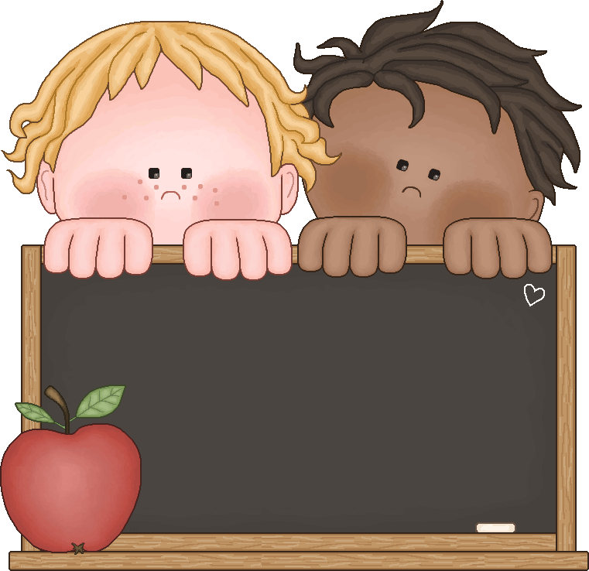
Clemens Primary School
Parent/Student
Handbook
2022-2023
Table of Contents

Letter to Parents-------------------------------------------- Page 3
Mission Statement ------------------------------------------ Page 4
Staff List/Contact Information---------------------------- Page 5
Daily Schedule ----------------------------------------------- Page 6
Extreme Weather and Disaster Policy --------------------- Page 7
Medication Policies and Procedures ------------------------ Page 8
Behavioral Mission Statement ------------------------------ Page 9
Attendance/Illness While at School ----------------------- Page 10
School and Playground Rules -------------------------------- Page 11
Principal’s Plan for Behavior Management ------------------ Page 12
School Bus Safety--- ---------------------------------------- Page 13
Volunteer/Visitor Policy------------------------------------- Page 14
School Lunch Program Information ------------------------ Page 15
Clothing ------------------------------------------------------ Page 16
Student Illness --------------------------------------------- Page 17
Response to Instruction and Intervention (RTIi) -------- Page 18
School Counseling Services--------------------------------- Page 19
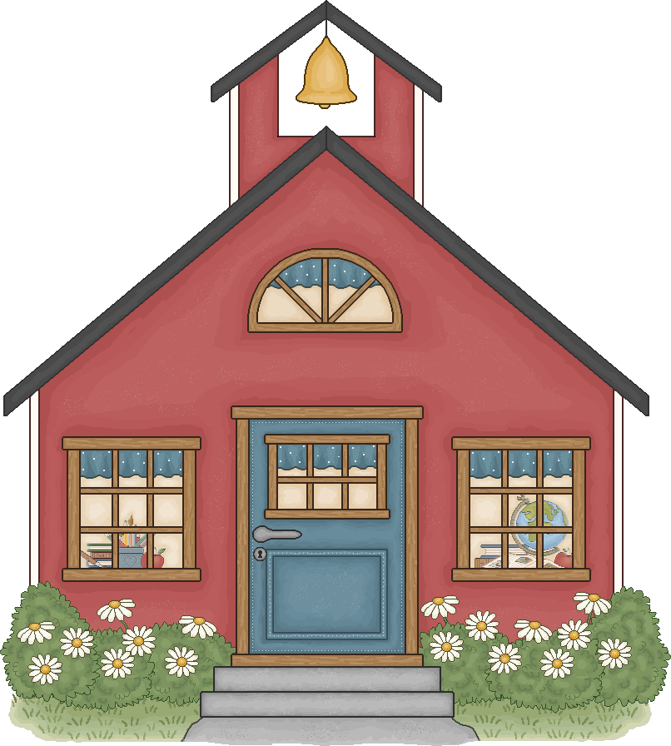

Dear Parents,

This parent handbook was developed to provide helpful information to you concerning our school programs and policies. We believe that positive communication between home and school is essential. One way I communicate is through the Cub Update Newsletter. This newsletter highlights important school events, community opportunities, and classroom news. Look for this newsletter each Friday during the school year.

We have approximately 200 students enrolled in grades PK-1. We offer one preschool (Next Steps) within the building, specialized speech and language services, RTI (Response to Intervention) programs, and SMART (Start Making a Reader Today) opportunities. We also provide an inclusion program for children with special needs. Music and physical education classes are scheduled twice a week for all of our KG and 1st grade students, and library services are offered once a week.

Clemens Primary is fortunate to have an exceptional staff of teachers, specialists and instructional assistants. We are dedicated to providing instruction that allows each student to demonstrate their personal best-academically, physically, socially, emotionally, musically, and artistically.

Best wishes for an enjoyable year,

Abby Couture
Principal

Clemens Primary School’s Mission Statement

The Clemens staff is committed to creating a positive learning environment in which all students learn to think critically, creatively and reflectively. Students will learn to communicate through reading, writing, speaking and listening. They will use current technology, apply science and math concepts, participate as a member of a cooperative them, demonstrate mastery and application of knowledge, and become self-directed learners.

We believe:

- Family and school are partners in helping each child reach their full potential, and in the development of a life-long love of learning.

- Children bring their own sets of unique experiences to the learning environment that enhances their ability to construct knowledge.

- Children learn responsibility by solving problems and experiencing the consequences of their decisions.

Clemens Primary School Staff
2021-2022

Administration:
Abby Couture – Principal Abby.Couture@philomath.k12.or.us
Certified Staff:
Robert Brown - Special Education Robert.Brown@philomath.k12.or.us
K’Lynn Coleman – RTI Specialist Klynn.Coleman@philomath.k12.or.us
Mallory Crane - Counselor Mallory.Crane@philomath.k12.or.us
Nick Burnett - PE Nick.Burnett@philomath.k12.or.us
Alyssa Blackstone - 1st Teacher Alyssa.Blackstone@philomath.k12.or.us
Susan Hobbs - 1st Teacher Susan.Hobbs@philomath.k12.or.us
Keri Gross - KG Teacher Keri.Gross@philomath.k12.or.us
Brittney Kampfer- KG Teacher Brittney.Kampfer@philomath.k12.or.us
Kirsten Davis – Speech Kirsten.Davis@philomath.k12.or.us
Melissa Malusky - 1st Teacher Melissa.Malusky@philomath.k12.or.us
Hailey Vandewiele – Music Hailey.Vandewiele@philomath.k12.or.us
Alice Ochs - KG Teacher Alice.Ochs@philomath.k12.or.us
Charlene Opheim – KG Teacher Charlene.Opheim@philomath.k12.or.us
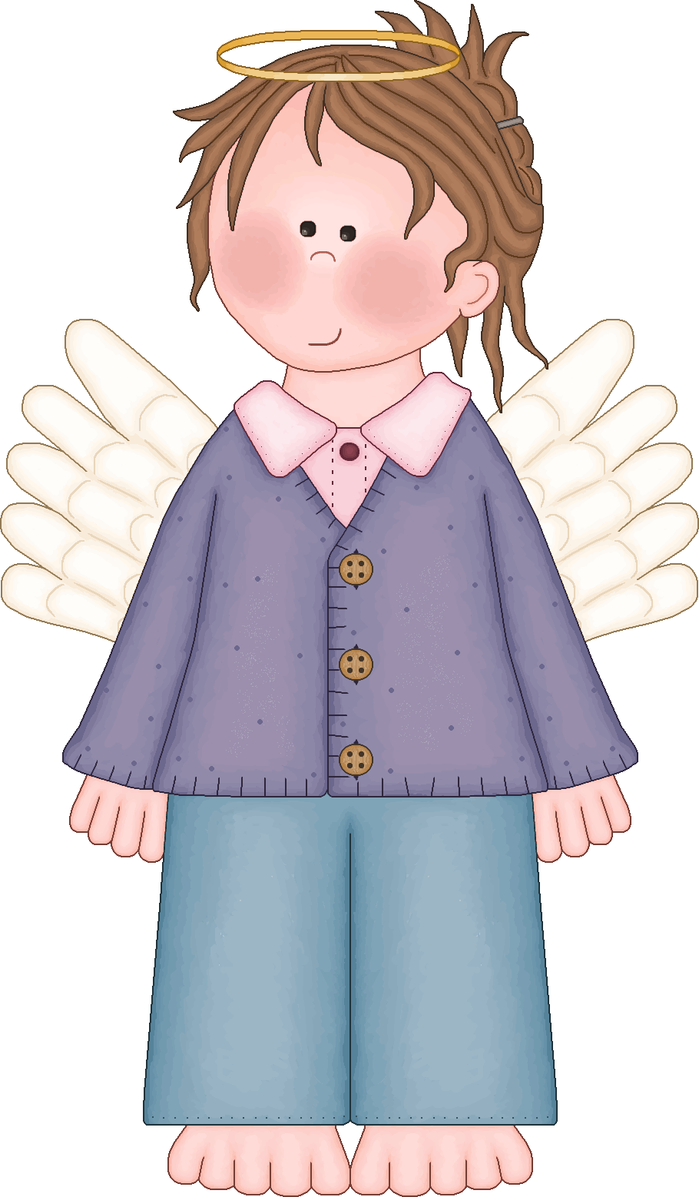
Julie Rain – 1st Teacher Julie.Rain@philomath.k12.or.us
Classified Staff:
Chris Boggs ……………………………………… Custodian
Danielle Carter ………..……………………….. Instructional Assistant
Kelly Davis ……………………………………… Office Manager
Laura Kildea ……..……………………………. Instructional Assistant
Lisa Hamilton ………………………………….. Instructional Assistant
BreeAnn Liddle ………………………………… Office Manager
Sierra Lynn …………………………………….. Instructional Assistant
Carol Pearson…………………………………… Instructional Assistant
Debbie Johnson ………………………………… Librarian
Tressa Remington ……………………………… Instructional Assistant
Darla Schwinabart ……………………………… Instructional Assistant
Cole Wilson …………………………………….. Instructional Assistant
Daily Schedule

PRE-SCHOOL
NEXT STEPS Mondays and Wednesdays Session 1: 8:30-11:30
Tuesdays and Thursdays Session 2: 12:00-3:00

KINDERGARTEN & FIRST
Monday - Thursday 8:15 AM – 2:45 PM
Friday 8:15 AM – 12:15 PM

LUNCH/RECESS
Kindergarten Gross/Kampfer = 11:15-11:35
Ochs/Opheim = 11:35 – 11:55
First Grade Blackstone/Hobbs = 12:05 – 12:25
Malusky/Rain = 12:25-12:45
First Grade 12:00-12:40
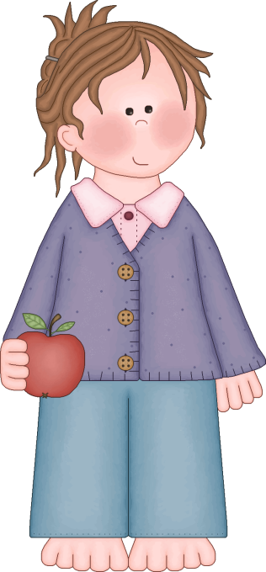
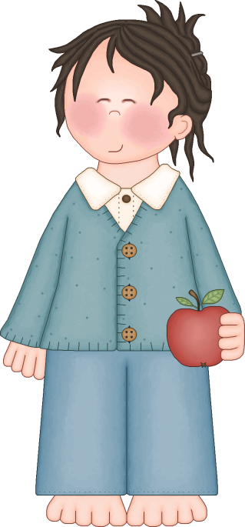
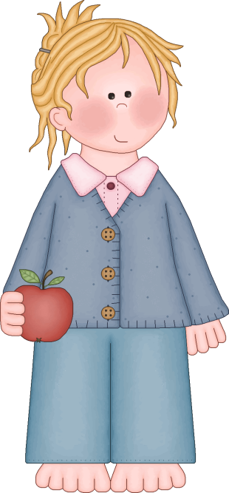
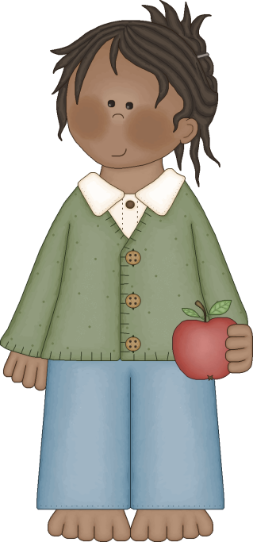

Extreme Weather and Disaster Information

Local radio and news stations will be notified when school is closed or the buses are running on a different schedule. When we experience inclement weather, power outages, or other natural disasters, the following radio and news stations will provide you with closure and schedule information:

KLOO 1340AM KFLY 1240AM KRKT 990AM KGAL 920AM
KWIL 790 AM KFAT 106.1FM KEJO 101.5FM KRKT 99.9FM

When there is a delayed start of school due to inclement weather or other reasons, such as a power outage, Pre-school will be canceled for the day.

Administering Medication to Students
Requests for designated school staff to administer medication to students may be approved by the district as follows:
- A written request for the district to administer prescription medication must be submitted to the school office. The request must include:
- The written signed permission of the parent or legal guardian;
- The written instructions from the physician for the administration of the prescription medication to the student including:
- Name of student;
- Name of the medication;
- Address;
- Dosage
- Frequency of administration;
- Other special instructions, if any.
The prescription label will be considered to meet this requirement if it contains the information listed in a–f above.
- A written request for the district to administer non-prescription medication must be submitted to the school office. The request must include:
- The written signed permission of the parent or legal guardian;
- The written instruction from the parent or guardian for the administration of the non-prescription medication to the student including the information listed in a. – f. above.
- Medication is to be submitted in its original container;
- Medication is to be brought to and returned from the school by the parent;
- It is the parent’s responsibility to ensure that an adequate amount of medication is on hand at the school for the duration of the student’s need to take the medication;
- It is the parent’s responsibility to ensure that the school is informed in writing of any changes in medication instructions;
- In the event a student refuses medication, the parent will be notified immediately. No attempt will be made to administer medication to a student who refuses district administered medication;
- Any error in administration of medication will be reported to the parent immediately (and documentation made on the district’s Accident/Incident Report Form);
- Medication shall not be admini stered or self-medication allowed until the necessary permission form and written instructions have been submitted as required by the district.

Self-medication of prescription or non-prescription medication is not allowed except in cases where a student must carry such medication on his/her person for immediate access. The parent or guardian must complete and turn in a permission form at the school office, and written instructions must be submitted as required above (a. – f.).

Clemens Primary Positive Behavioral Intervention System

Students and staff at Clemens Primary School desire a learning environment that maximizes learning opportunities. Our philosophy is based on respect for others. Our social emotional curriculum, Kelso’s Choice, is built around guidelines and skills we all use in daily life. The Clemens Primary behavioral mission is based on caring for ourselves, caring for each other, caring for our school environment, and caring about learning.

Throughout the school year we will focus on the following skills:

Kindness – saying nice things to others and thinking about their needs.
Responsibility – to respond when appropriate, to be accountable for your actions
Respect – showing high regard for people in authority and treating others the way you want to be treated
Gratitude – being thankful and celebrating the joys and accomplishments of others
Honesty – to be truthful, fair and straightforward of conduct
Resiliency –Completing tasks even when they are difficult and you may want to quit.
Courteousness – treating others with respect and kindness
Caring – to feel and show concern for others
Empathy – Listening and respecting others’ ideas and opinions and imagining how others might be feeling.
Cooperation – to work together toward a common goal or purpose
Integrity – to act according to a sense of what is right and what is wrong
Citizenship – obeying the rules of the school and doing things to make my school and community a better place
Self-Control – thinking about actions before doing them and saying “no” to situations that could get you into trouble.
Compassion – recognizing when others are sad or hurt and doing your best to help them
Patience – to take turns and wait peacefully for my turn

Attendance

Our attendance policy is based on the belief that school success is strongly related to regular and punctual attendance by all students. We encourage you to help your child to make it a habit to be on time and to attend school each day.

Students are not permitted to leave the school grounds once they arrive at school unless they are picked up by a parent or guardian.

We account for each child in the school every day. If your child will be absent, parents are requested to call the school before 8:30 a.m. If no call is received, you will be called.

Students released for doctor or dental appointments should check out in the office before they leave school. They should also check back in at the office if they return prior to the end of the school day. A note or phone call from the parent regarding the appointment is very helpful. We urge you to schedule appointments outside school hours whenever possible.

Parents are asked to submit a “Pre-Excused Absence Request Form” prior to taking their child out of school for more than one day. You may find this form on our school website by clicking the link “Pre-Excused Absence Request Form”. When parents request a prearranged absence for their child, they will be asked to give 2 weeks advanced notice.

In order to provide maximum protection for your child, please
call the office if you wish to allow your child to
leave school with someone other than a parent or guardian.

School and Playground Rules
The following school and playground rules were developed to provide a safe and positive environment for Clemens Primary students. For security and safety reasons, students MUST leave electronic devices, skates, roller blades, and skateboards at home. Weapons and/or “look alike” weapons are not permitted. In addition, toys from home (including trading cards) are not permitted in school.
Clemens Primary students will:
Be respectful
Be responsible
Be safe
Do your best!
The following behaviors are NOT PERMITTED in school or on the playground:
Showing disrespect to staff or other students
Fighting (including play fighting)
Swearing
Stealing
Bullying, intimidating, or threatening other students
Throwing rocks, snowballs, or other dangerous items
Misuse of play equipment
Damaging school property and the property of others
Leaving school grounds without permission
CONSEQUENCES FOR INAPPROPRIATE BEHAVIOR MAY INCLUDE:
Talking with the playground supervisor/teacher
Isolating student from other students for short periods
Loss of privilege
Contacting parent(s) in cases of repeated problems
Referring student to the building principal
IMMEDIATE REFERRAL TO THE PRINCIPAL FOR:
Fighting and/or intentionally causing physical injury to others
Using racial slurs
Showing disrespect to adults
Leaving school grounds without permission
Extreme swearing
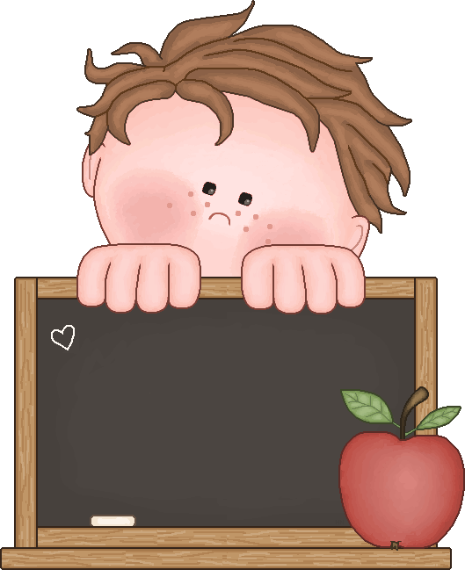
Oops!

Each behavior incident that is referred to the principal is carefully evaluated with input from the student(s) and adult(s) involved. The principal strives to be fair and consistent, and wants to ensure that the specific discipline strategies selected are appropriate for the rule(s) that have been broken. These strategies may include one or more of the following:

- Talking with the student
- Sending a Behavior Referral home to be signed and returned
- Restricting the student from recess
- Restricting the student from participation in instructional classes
- Contacting parents by phone and/or letter
- Recommending student be taken home early and/or not attend school for a day
- Withdrawing a student’s special privileges (for example, viewing a video, attending an assembly, participating in a field trip, etc.)
- Recommending that a student work with interventionists (counselor or ESD personnel) upon parent approval

The principal may elect to utilize formal suspension or expulsion procedures pursuant to state law in extreme discipline cases.

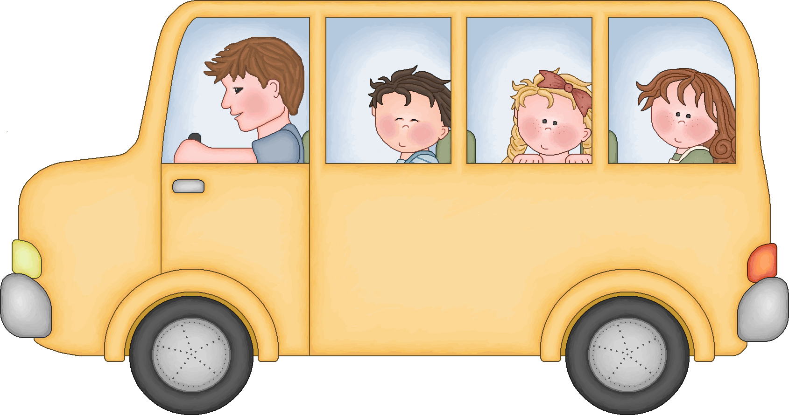
School Bus Safety

We want the school bus ride to be a safe and pleasant experience for all children. The bus drivers and teachers will review the safety rules with the children. We would also like the parents to stress to their children that they follow all the rules. The following are some of the safety rules:

- Students must follow all directions the first time given.
- Students are to remain seated while the bus is in motion.
- Students will be courteous to the driver, fellow students, and passers-by.
- Pets, class items, or potentially hazardous materials are not allowed on school buses.
- Safety rules apply when children are waiting at bus stops.
- When crossing the road, students will cross in front of the bus or as instructed by the bus driver.
- Students must have written permission from a parent or guardian to ride a different bus than usual or get off at a different stop. These notes are first given to the teacher, then to the front office, and then to the bus driver by the student.
- Students who refuse to promptly obey the directions of the bus driver or refuse to obey regulations may forfeit their privilege to ride on the bus.

Special Note: Children who ride the bus are returned to school if a parent is not present at the bus stop to pick up their child.

Volunteers and Visitors

We value the assistance and dedication of all or our classroom helpers. They provide a worthwhile and immeasurable service to our children and staff!

For the safety of our students, we require that all volunteers undergo a background check before working with children. This can be accomplished easily on our school website by clicking the “Volunteer at CPS!” link and submitting your application.

Once approved, we ask visitors and volunteers to check in and out of the school office. We ask that you prearrange visits to your child’s classroom with the teacher to avoid disruption of the learning process.

School Lunch Information

A hot lunch with a planned, balanced menu is served daily. Students are offered two lunch choices. One is a hot lunch entrée and the other is a peanut butter and jelly sandwich.

The cost for these items is:
Breakfast - $2.00
Lunch - $3.00
Milk - $0.60

Students make these choices when first arriving in the morning. Please help your child understand that once they make a choice in the morning they can’t change their mind to a different option when they arrive to the lunchroom.

If you are interested in submitting an application for free/reduced lunches, you may do so by visiting our school website and clicking on the “Food Services” link. There you will find the application needed. We also have paper copies in the front office.

Clothing

It has been our experience that parents send their children to school in clothing that is clean, neat, and in good taste. Occasionally we ask students to choose a shirt/pants from the office if their clothing is deemed inappropriate for school.

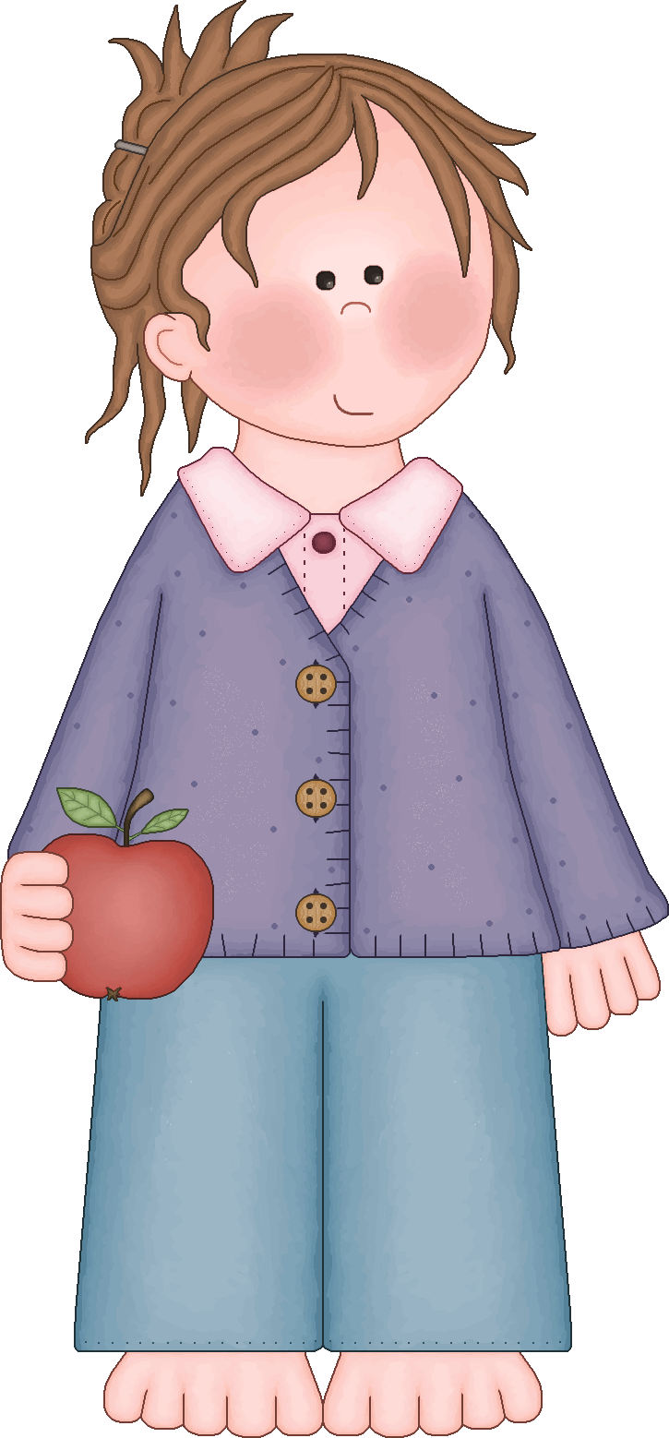
The following is a list of clothing items that are inappropriate to wear to school:
- Hats
- Short shorts/skirts
- Half shirts (showing midriff)
- Clothing depicting alcohol, drugs, cigarettes, or inappropriate pictures/language
- Spaghetti strap shirts/dresses that do not fit properly
- Flip Flop shoes
- See through tops/bottoms

School and Illness: Should Your Child Stay Home?

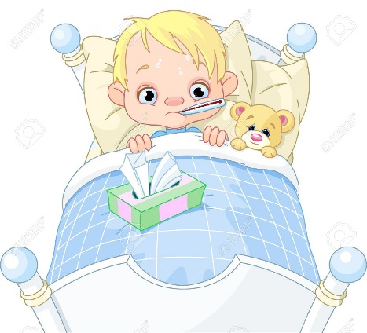
Your child is too ill if he or she has any of these symptoms:
* Seems very tired and needs bed rest
(this is common with flu symptoms)
* Has vomiting or diarrhea
(Do NOT send until student is FREE OF SYMPTOMS for 24 hours)
* Becomes short of breath or is wheezing
* Has a cough that disrupts normal activity
* Has distracting pain from earache, headache, sore throat or recent injury
* Has yellow or green drainage from eye(s)
* Breaks out in a rash; not all rashes require that a child stay home from school. Check with your child’s doctor. Impetigo would require staying home until treated with an antibiotic for 24 hours.
* Live lice visible in hair. Treat. Student may return after no live lice are found in hair after treatment.
*Fever: Your child should not go to school if they have a temperature at or above 100.0* F. Students may return to school after they are feeling better (a temp. below 100.0*F without a fever reducer in their system).

Contagious Disease:
Your child should stay home from school if he/she has a contagious disease. A contagious disease is one that can be spread by close contact with a person or object.
Examples are: COVID-19, chickenpox, flu, vomiting, diarrhea, colds, strep throat and conjunctivitis (pinkeye).

A disease may be contagious before the child shows signs of illness. It is very hard to prevent the spread of some germs, especially in a school classroom. Good hand washing will help prevent the spread of germs in most settings.
* If your child has COVID-19, chickenpox or strep throat, please ask your doctor when he/she may return to school. In general, children who have active chickenpox should not return to school until all the lesions are dried and crusted.
* Children with strep throat should be on antibiotics for 24 hours and feeling well enough to concentrate.

Response to Instruction and Intervention (RTIi)

RTI is a process that provides intervention and educational support to all student at increasing levels of intensity based on their individual needs. The goal is to prevent problems and intervene early so students can be successful learners. Areas of intervention include: reading, math, and behavior.
This model includes:
- High quality, research-based instructional and behavior supports in the general education setting.
- School-wide screening to determine which students need closer monitoring or additional interventions.
- Multiple tiers of increasingly intense, research-based interventions matched to the needs of the student.
- Use of collaborative problem solving to develop, implement, and monitor student interventions.
- Continuous monitoring of student progress to determine if instruction/interventions are effective in meeting the needs of the student.
- Follow-up to ensure that the instructional interventions were implemented as planned.

The RTI process has three tiers that build upon one another. Each tier provides more intensive levels of support:
Tier 1: The school provides all student with access to high quality curriculum, instruction, and behavior supports in the general education classroom.
Tier 2: The school provides interventions to small groups of students who need more support than they are receiving through Tier 1.
Tier 3: The school develops and implements interventions to meet the individual needs of students. Your child’s progress is monitored and results are used to make decisions about additional instruction and intervention.
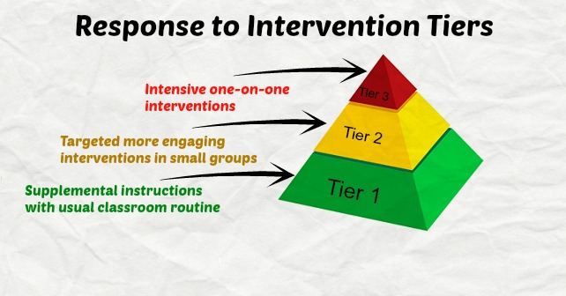

School Counseling Services

Philomath Schools provide school counselors at all K-12 schools. The role of the school counselor is to support students academically, personally, and socially, as well as introducing students to life skills which will help them to be successful in their education and career journeys.

Ms. Crane provides school counseling services at Clemens Primary School. Below is a list of the three main categories of services provided to students with a brief description following:
- Classroom Guidance: Students in all classes are taught lessons focusing on social and emotional skills, problem solving, friendship building, etc.. Lessons are taught using research based curriculum and activities.
- Small Group Counseling: When students have needs that are more personal and can’t be addressed in class, students, parents and staff may refer a child for a small group. Small groups include topics such as family changes (divorce), bereavement, self-esteem, friendship and anger management, etc.. Groups typically meet for 6-8 weeks and are usually held during an agreed upon time once a week. Other topics are offered when needs are identified by parents and/or teachers. Small groups are confidential and always positive in nature to provide the support the students need.
- Individual Check-ins: Periodically through the school year, students may need support in an even smaller setting. Individual check-ins are provided to any student with personal or social needs that hinder the child’s success at school. Individual check-ins are confidential though children are encouraged to share discussions with adults they trust such as teachers and parents/guardians.
How can a child be seen by the school counselor?
Parents can call the school counselor at (541) 929-2082x4125 or email at mallory.crane@philomath.k12.or.us to refer their child or to discuss activities at school. Teachers and students also may refer for either small groups or individual counseling.
Why is school counseling confidential?
School counselors are required to uphold the ethical standards of the American School Counseling Association (ASCA) stating that student information shared with the school counselor stays between the student and the school counselor unless they are being hurt, someone is hurting them, or they are thinking of hurting themselves. It is important that students know they have a trusted adult they can speak with at school. In order for students to trust the school counselor with feelings and problems, conversations are kept confidential. Students are encouraged to share conversations with trusted adults if they feel safe to do so.
If my child sees the school counselor can I speak with the school counselor?
Of course! Though a school counselor won’t share specifics, general themes can be shared as well as ideas to help. If you have any questions for Ms. Crane please call or email anytime. Communication is encouraged and appreciated!

